**W5100:**

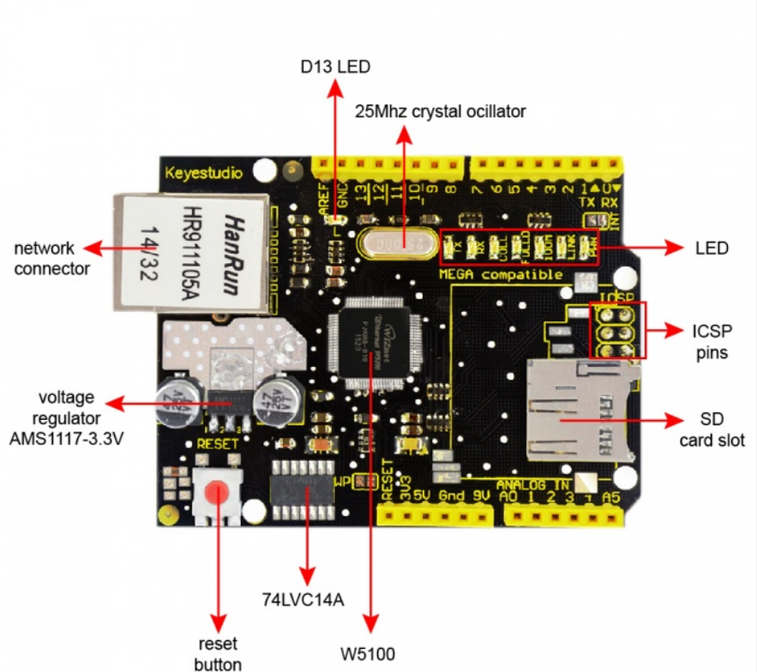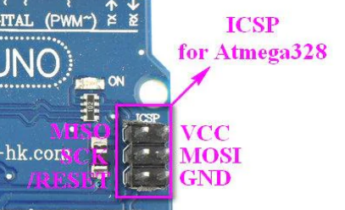

**ICSP Pins**

**MISO | | VCC+**

**SCK | | MOSI**

**RESET | | GND**

**Datapins :**



